**UNIT III**

**TRANSFORMERS**

Transformer is an ac machine; the main advantage of alternating currents over direct currents is that, the alternating currents can be easily transferable from low voltage to high or high voltage to low.

Alternating voltages can be raised or lowered as per the requirements in the different stages of electrical network as generation, transmission, distribution and utilization. This is possible with a device called transformer.

Definition:

Transformer is a static piece of apparatus by means of which electrical power is transferred from one alternating current circuit to another with the desired change in voltage or current and without any change in the frequency.

Principle of operation:

It is a static machine and it works on the principle of statically induced emf. It consists of:

* + Magnetic circuit and
  + 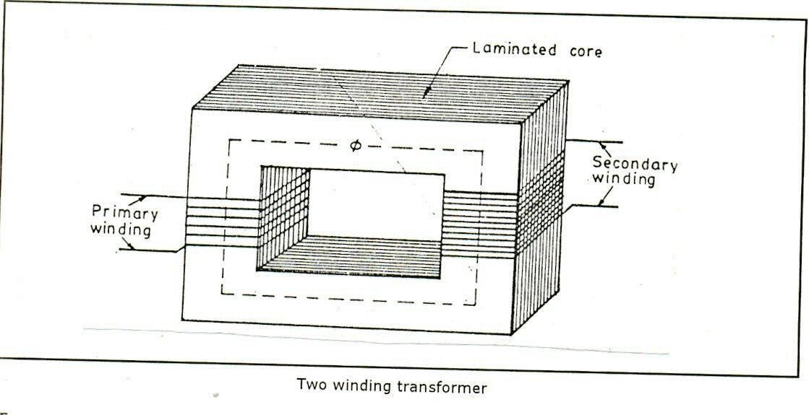Electric circuit

Two separate electrical windings are linked through a common magnetic circuit. The two electrical windings are isolated from each other.

The coil in which electrical energy is fed is called primary winding while the other from which electrical energy is drawn out is called secondary winding.

The primary winding has N1 number of turns while secondary winding has N2 number of turns.

When primary winding is excited by alternating voltage say V1, it circulates alternating current I1 through it. This current produces an alternating flux ‘’ which completes its path through the common magnetic core.

This flux links with both the windings. Because of this, it produces self induced emf E1 in the primary winding while due to mutual induction i.e. due to flux produced by primary linking with secondary, it produces induced emf E2 in secondary winding.

These emf’s are:

*E*   *N d*

1 1

*dt*

*E*   *N d*

*dt*

2 2

If now secondary circuit is closed through the load, the mutually induced emf in the secondary winding circulates current through the load. Thus electrical energy is transferred from primary to secondary with the help of magnetic core. A voltage V2 appears across the load. Hence V1 is the supply voltage, while V2 is the secondary voltage when load is connected, then:

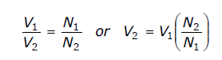

*k*  *N*2

*N*1

 *E*2 

*E*1

Transformation ratio

If k > 1, then V2 > V1, transformer is called step up transformer.

If k < 1, then V2 < V1, transformers is called step down transformers.

If k = 1, then V2 = V1, then transformer is called one to one transformer.

The current flowing through primary is I1 and when load is connected current I2 flows through secondary voltage. The power transfer from primary to secondary remains the same. Assuming both primary and secondary power factor to be the same, we can write:

Power input to primary = Power output from secondary V1 I1 = V2 I2

*V*1  *I*2  *N*1  *E*1

*V*2 *I*1 *N*2 *E*2

Construction of a transformer:

*There are basic parts of a transformer:*

1. Magnetic core
2. Windings or coils
3. Tank or Body
4. Conservator Tank
5. Breather
6. Radiator
7. Bushings

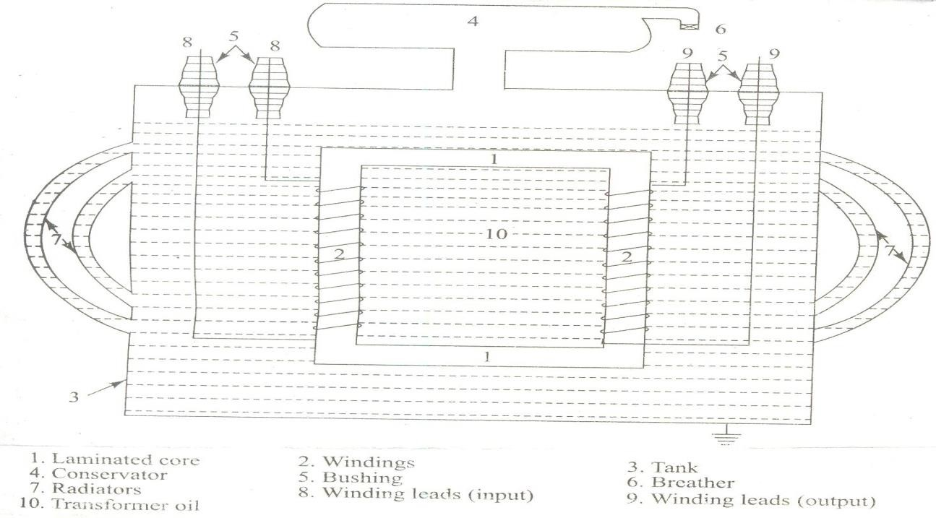

**Core**: The transformer core is made of silicon steel or sheet steel with 4 % silicon. The sheets are laminated and are coated with Oxide layer to reduce iron losses. The thickness of lamination is 0.35mm for 60 Hz and 5mm for 25Hz.

The core of the transformer is either square or rectangular in size. It is further divided in to two parts. The vertical portion on which coils are wound is called limb while the top and bottom horizontal portion is called yoke of the core.

The core is made up of laminations. Because of laminated type of construction, eddy current losses get minimized. Generally high-grade silicon steel laminations are used. These laminations are insulated from each other by using insulation like varnish.

The purpose of the core is to provide magnetic path of low reluctance between the two windings so that the total flux produced by one of the winding will be linked fully with the other winding without any leakage.

**Windings**: A transformer has two windings. The winding which receives electrical energy is called Primary winding and the winding which delivers electrical energy is called Secondary winding. Windings are generally made up of High grade copper. The windings are provided with insulation so that one winding may not come in contact with the other winding. Generally cotton, Paper and Oxide layer is used as insulating medium.

**Tank or Body**: It is part which is meant to carry the transformer and the oil used in the transformer. The tank used for a transformer should be air tight so that moisture should also not enter into the tank so as to maintain the properties of the transformer oil.

**Transformer Oil**: It is the most important part of a transformer which decides the life of a transformer. The oil that is used in a transformer should be safe guarded properly so as to have a good life for a transformer.

**Conservator Tank**: When a transformer is oil filled and self cooled the oil in the tank is subjected to heat and thus will naturally expand and contract due to variations in the load current and is also subjected to seasonal variations. The conservator tank provides the means for the oil to settle down by expanding under heavy loads.

**Breather**: Transformer oil should not be exposed to atmosphere directly because it may absorb

Moisture and dust from the environment and may loose its electrical properties in a very short time. To avoid this from happening a breather is provided. The breather completely prevents the moisture and dust from coming into contact with the oil in the conservator tank when it expands or contracts.

**Bushings**: The purpose of Bushings is to provide proper insulation for the output leads to be taken out from the transformer tank. Bushings are generally of two types.

1. Porcelain type which are used for voltage ratings uptp33kv
2. Condenser type and Oil filled type are used for rating above 33kv

**Radiator**: These are meant to increase the surface area of the tank also to provide a path for the circulating of the transformer oil.

**Types Of Transformers:**

The transformers are classified based on the relative position or arrangement of the core & the windings, based on cooling and based on Voltage.

1. Based on arrangement of the core & the windings transformers are classified as
   * Core type
   * 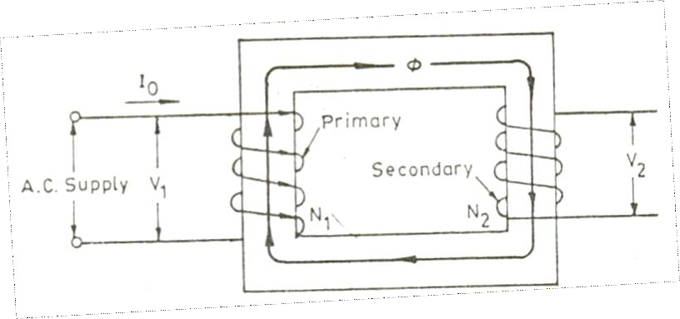Shell type

Core type Transformer

It has a single magnetic circuit. In this type, winding encircles the core, coils used are of cylindrical type. Such coils are wound in helical layers with different layers insulated from each other by paper, cloth, mica, etc. Core is made up of large number of thin laminations to reduce eddy current losses.

The windings are uniformly distributed over two limbs and hence natural cooling is more effective.

The coils can be easily removed by removing laminations of top yoke for maintenance.

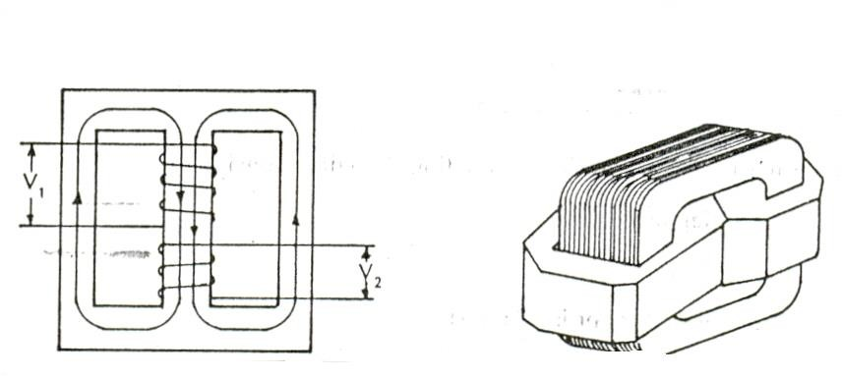

Shell type transformer

It has a double magnetic circuit. In this type core encircles the most part of the winding. The core is again laminated one and while arranging the laminations, care is taken that all joints at alternate layers are staggered.

This is done to avoid narrow air gap at the joint, right through the cross section of the core.Such joints are called as overlapped. The coils are multi-layered disc type or sandwich type coils and are placed on only one limb and are surrounded by the core. So natural cooling does not exist.

1. Based on Voltage
   * Step up
   * Step Down

Step up transformer is a transformer where the Output Voltage is greater than input Voltage i,e V2>V1

Step down transformer is a transformer where the Output Voltage is less than input Voltage i,e V2<V1

Transformation Ratio =V2/V1=N2/N1

Where N2,N1 are number of turns in secondary and primary windings.

1. Based on cooling:
   * Oil cooled
   * Oil filled water cooled
   * Air cooled

### EMF equation of a transformer:

Primary winding is excited by a voltage, which is alternating in nature. This circulates current through primary, which is also alternating and hence the flux produced is also sinusoidal in nature.

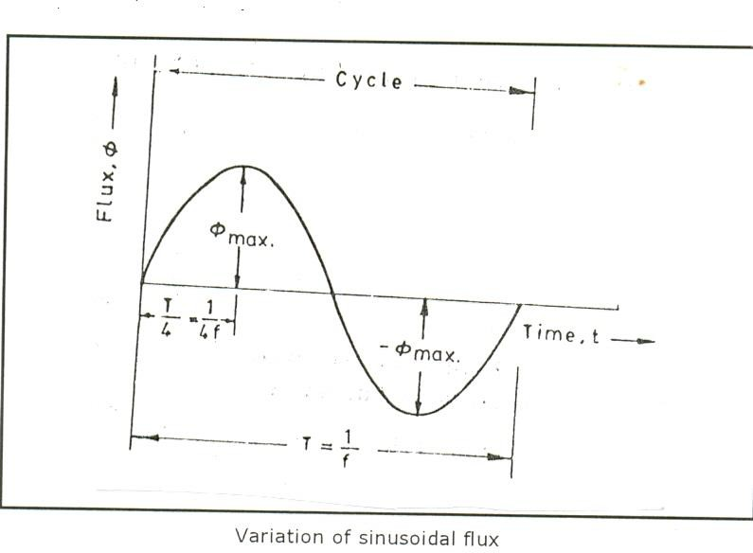

Let  = flux in the core

 m = Bm X A

N1 = number of turns in the primary winding N2 = number of turns in the secondary winding f = frequency of ac input in Hz.

The flux increases from its zero value to maximum value m in one quarter of the cycle i.e., in ¼ f second.

Average rate of change of flux = *m*

¼ *f*

= 4 f  m wb/sec

Rate of change of flux per turn means induced emf in volts Average emf / turn = 4 f m volt.

If flux  varies sinusoidally then rms value of induced emf is obtained by multiplying the average value with the form factor.

Form factor =

*rms vaue average value*

 1.11

rms value of emf/ turn = 1.11 x 4 f m = 4.44 f m

Now rms value of induced emf

in the whole of primary winding = induced emf / turn x number of primary turns E1 = 4.44 f N1 m = 4.44 f N1 Bm A

Similarly, rms value of emf induced in secondary is: E2 = 4.44 f N2 m = 4.44 f N2 Bm A

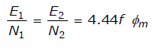

That is, emf/ turn is same in both primary and secondary windings.

In an ideal transformers on no load V1 = E1 & E2 = V2 Where, V2 is the terminal voltage.

Ideal transformers

*Transformer is called ideal if it satisfies the following properties:*

1. It has no losses
2. Its windings have zero resistance
3. Leakage flux is zero i.e. 100% flux produced by primary links with the secondary
4. Permeability of core is so high that negligible current is required to establish the flux in it.

An ideal transformer is one which has no loses i.e., its windings have no ohmic resistance, there is no magnetic leakage and hence which has no I2R and core losses. In other words, **an ideal transformer consists of two purely inductive coils wound on a loss free core.**

Problems:

1. The maximum flux density in the core of a 250/3000 volts, 50 Hz single phase transformer is 1.2 wb/m2. If the emf per turn in 8 volt, determine
   1. primary and secondary turns B) area of the core

Solution: a) E1 = N1 x emf induced / turn

N1 = 250/8 = 32 N2 = 3000/8 = 375

* 1. E2 = 4.44 f N2 Bm A

3000 = 4.44 x 50 x 375 x 1.2 x A A = 0.03 m2.

1. A single phase transformer has 400 primary and 1000 secondary turns. The net cross sectional area of the core is 60 cm2. If the primary winding be connected to a 50 Hz supply at 520 V, calculate:
   1. peak value of flux density in the core
   2. the voltage induced in the secondary winding.

Solution: K = N2/N1 = 1000/400 = 2.5

a) E2/E1 = k E2 = k E1= 2.5 x 520 = 1300 V

b) E1 = 4.44 f N1 Bm A 520 = 4.44 x 50 x 400 x Bm x 60 x 10-4.

Bm = 0.976 wb/m2.

Transformer on No-load:

An ideal transformer is one in which there were no core losses and copper losses. But practical conditions require that certain modifications be made in the foregoing theory. When an actual transformer is put on load, there is iron loss in the core and copper loss in the winding (both primary and secondary) and these losses are not entirely negligible.

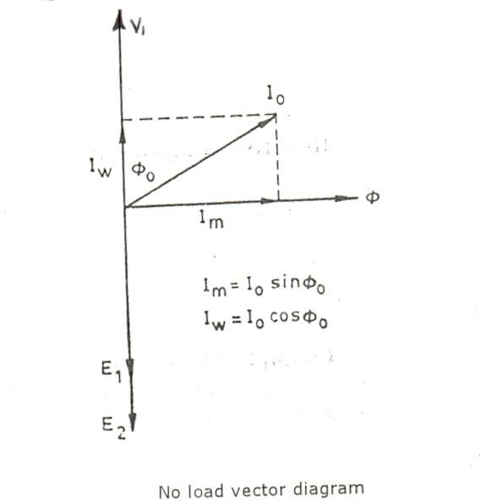

Even when the transformer is on no-load the primary input current in not wholly reactive.

The primary input current under no load conditions has to supply (1) iron losses in the core i.e. hysteresis loss and eddy current loss and (2) a very small amount of copper loss in primary (there being no copper loss in secondary as it is open).

Hence, the no load primary input current Io is not at 90o behind V1 but lags it by an angle 0< 90o. No load input power Wo = V1 Io coso, Where coso is primary power factor under no load condition.

*The primary current Io has two components*:

1. One in phase with V1. This is known as active or working or iron loss component Io because it mainly supplies the iron loss plus a small quantity of primary copper loss.

Iw = Io cos o.

1. The other component is in quadrature with V1 and is known as magnetizing component I because its function is to sustain the alternating flux in the core. It is watt-less.

I = Io sin o

*I* 2  *I* 2

** *w*

Obviously, Io is the vector sum of Iw and I, hence Io =

The following points should be noted carefully.

1. The no-load primary current Io is very small as compared to the full-load primary current. It is about 1 percent of the full load current.
2. Owing to the fact that the permeability of the core varies with the instantaneous value of the exciting or magnetizing current is not truly sinusiodal. As such, it should not be represented by a vector because only sinusoidally varying quantities are represented by rotating vectors.
3. As Io is very small, the no load primary copper loss is negligibly small which means that **no load primary input is practically equal to the iron loss in the transformer.**
4. As it is principally, the core loss which is responsible for shift in the current vector, angle **o is known as hysteresis angle** of advance.

Problem:

1. A 2,200/200–V transformer draws a no load primary current of 0.6 A and absorbs 400 watts. Find the magnetizing and iron loss currents.
2. A 2200 / 250-V transformer takes 0.5 A at a p.f. of 0.3 on open circuit. Find magnetizing and working component of no-load primary current.

a) Iron – loss current =

*no*  *load input in watts primary voltage*

*V*1 *Io* cos** 0

*V*1

Iw = 400/2200 = 0.182 A

*Now*

*I* 2  *I* 2  *I* 2

0 *w *

Magnetizing component I =  0.572 *A*

0.62  0.1822

c) Io = 0.5 cos0 = 0.3

Iw = I0 cos 0 = 0.5 x 0.3 = 0.15 A

I =  0.476 *A*

0.52  0.152

Transformer on load:

When the secondary is loaded, the secondary current I2 is set up. The magnitude and phase of I2 w.r.t. V2 is determined by the characteristics of load. Current I2 is in phase with V2 if load is non-inductive, it lags if load is inductive and it leads if load is capacitive. The secondary current sets up its own mmf (N2I2) and hence its own flux 2 which is in opposition to the main flux  which is due to I0.

The secondary ampere turns N2 I2 are known as demagnetizing ampere turns. The opposing secondary flux 2 weakens the primary flux  hence primary back emf E1 tends to be reduced. For a moment V1 gains the upper hand over E1 and hence causes more current to flow in primary. Let the additional primary current be I 1. It is known as load component of primary current. This current is in antiphase with I2.

2

The additional primary mmf N1 I 1 sets up its own flux  l which is in opposition to

2

2

2 (but is in the same directions as ) and is equal to it in magnitude. Hence, the two cancel each outer out. So, the magnetic effects of secondary current I2 are immediately neutralized by the additional primary current I l which is brought into existence exactly at the same instant as I2. **Hence whatever the load conditions, the net flux passing through the core is approximately the same as at no load.**

2

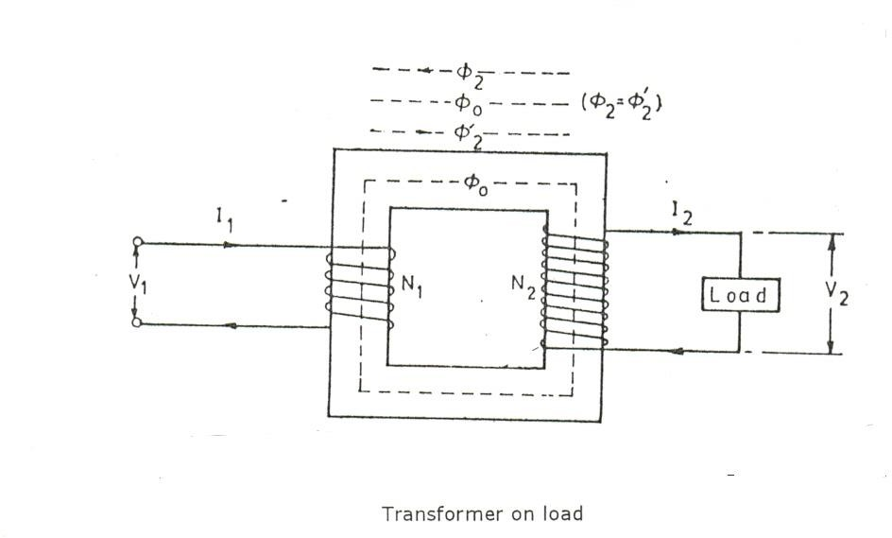

2 = 2l

N2 I2 = N1 I l

2

*l N*2

*I*



2 *N*1

*xI*2

 *kI* 2

Hence, when transformer is on load the primary winding has two currents in it; one is I0 and at the other is I 1which is anti-phase with I2 and k times in magnitude. The total primary current is the vector sum of I0 and I 1.

2

2

I1

I2’ = K I2 I0

I Iw

The vector diagrams for a loaded transformer when load is non-inductive, inductive and when it is capacitive is shown. Voltage transformation ratio of unity is assumed so that primary vectors are equal to secondary vectors.

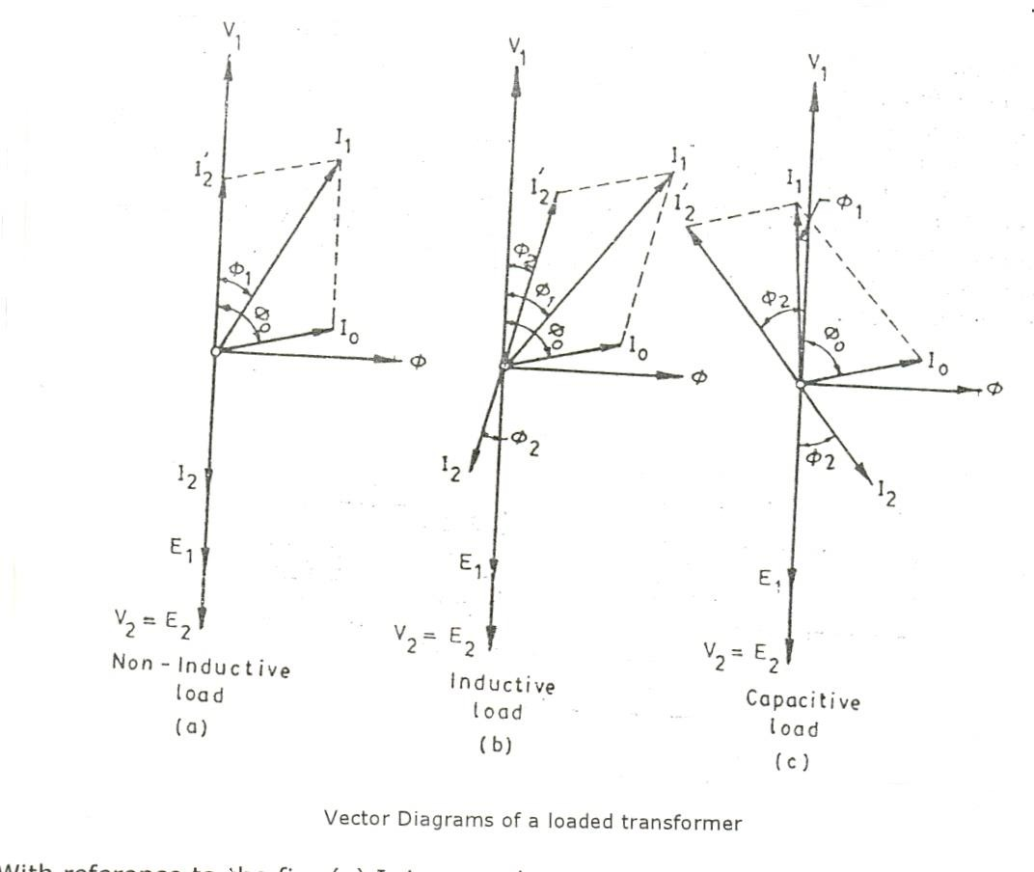

With reference to the fig. (a) I2 is secondary current in phase with E2 (it should be v2). It causes primary current I l which is anti-phase with it and equal to it in magnitude (k = 1). The total primary current I1 is the vector sum of I0 and I l and

2

2

lags behind V1 by an angle 1.

In (b) vectors are drawn for an inductive load. Here I2 lags E2 (actually V2) by 2.

Current I 1 is again in anti-phase with I2

2

and equal to it in magnitude. I1

is the

vector sum of I21 and I0 and lags behind V 1 by 1. In (c) vectors are drawn for a capacitive load.

Problems:

A single phase transformer with a ratio of 440/110-V takes a no-load current of 5A at 0.2 p.f. lagging. If the secondary supplies a current of 120 A at a p.f. of 0.8 lagging, estimate the current taken by the primary.

Cos 2 = 0.8

2 = cos-1 (0.8) = 360 54l

Cos 0 = 0.2

o = Cos (0.2) = 780 30l

Now K = V2 / V1 = 110/440 = 1/4 I l = K I = 120 x 1/4 = 30 A

2 2

I0 = 5A

Angle between I0 x I l

2

780 30l – 360 54l = 410 36l

Using parallelogram law of vectors, we get

I1 = = 34.45 A

52  302  2 *x* 5 *x* 30 *x* cos410 36|

Transformer with winding resistance but no magnetic leakage:

An ideal transformer posses no resistance, but in an actual transformer, there is always present some resistance of the primary and secondary windings. Due to this resistance, there is some voltage drop in the two windings. The result is that

1. The secondary terminal voltage V2 is vectorially less than the secondary inducted emf E2 by an amount I2 R2 where R2 is the resistance of the secondary winding. Hence, V2 is equal to vector difference of E2 and resistance voltage drop I2 R2.

**V2 = E2 – I2 R2.**

1. Similarly primary induced emf E1 is equal to the vector difference of V1 and I1 R1 where R1 is the resistance of the primary winding.

**E1 = V1 – I1R1**

Transformer with resistance and leakage reactance:

The primary impedance: *Z*1 

*R*2  *x*2

1 1

The secondary impedance: *Z*2 

*R*2  *x*2

2 2

The resistance and leakage reactance of each winding is responsible for some voltage drop in each winding.

In primary, the leakage reactance drop is I1 X1, hence

V1 = E1 + I1 (R1 + jX1) = E1 + I1 Z1. **E1 = V1 – I1 Z1.**

Similarly E2 = V1 + I2 (R2 + jX2)

= V2 + I2 Z2 **V2 = E2 - I2 Z2**.

The vector diagrams for such a transformer for different kinds of loads are shown, in the diagrams, vectors for resistive drops are drawn parallel to current vectors where as reactive drops are drawn perpendicular to current vectors.

Vector Diagram

Steps to draw vector diagram:

1. Draw a horizontal line to represent flux line and a vertical line to represent voltage axis.
2. Draw a line OA in the III quadrant at some inclination to represent V2 the terminal voltage.
3. Let I2 be the load current in line with V2 (resistive load)
4. At the tip of V2, draw AB parallel to I2 to represent I2 R2 drop (in line with V2)
5. At ‘B’ draw BC at right angles to AB to represent I2 X2 meeting the vertical line at ‘C’ then OC is equal to secondary induced emf E2.
6. Produce ‘O’ backwards to ‘D’ such that OD = OC/k then OD represents the primary induced emf.
7. Produce the current line I2 backwards to F such that OF = KI2. Let ‘OE’ be equal to the load current ‘I0’ at angle of ‘0’ from E1.
8. Construct the parallelogram OEGF then OG represents the primary current I1.
9. At the tip of E1 i.e. at D, draw DH equal to I1R1, parallel to OG. At ‘H’ draw ‘HJ’ perpendicular to DH to I1X1 drop
10. V1 is obtained by adding vectorially the impedance drop I2Z2 to -E1.

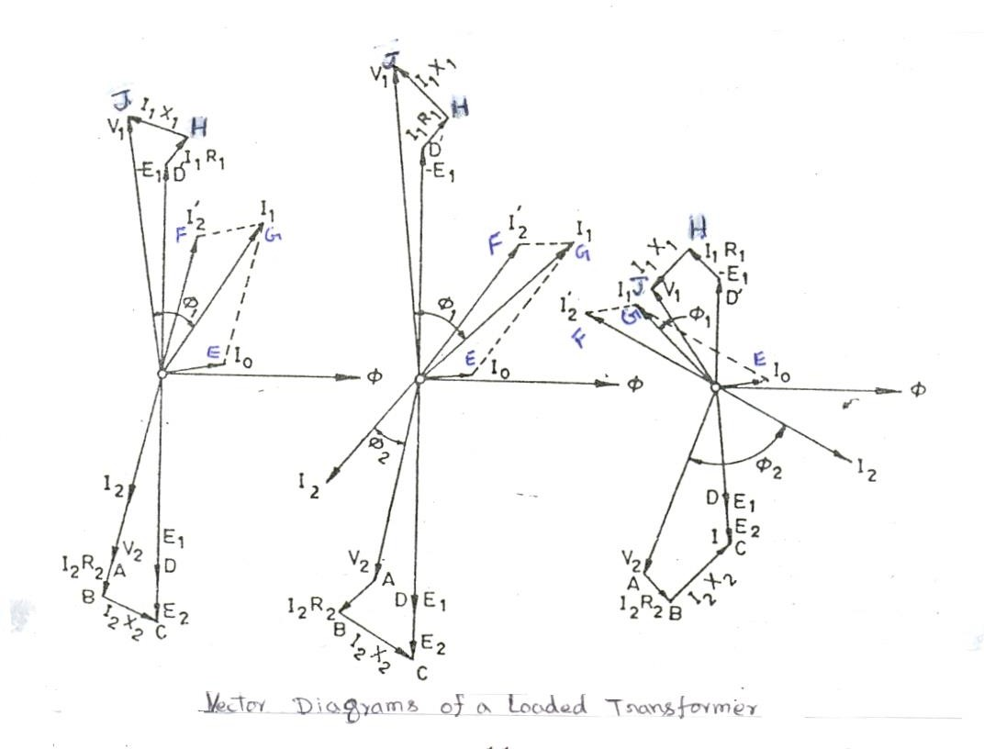

Equivalent Resistance:

A transformer with primary and secondary winding resistance of R1 and R2 can be transferred to any one of the two windings. The advantage of concentrating both

the resistances in one winding is that it makes calculations very simple and easy because one has then to work in one winding only.

A resistance of R2 in secondary is equivalent to R2/k2 in primary. The value R2/K2 will be denoted by R l – the equivalent secondary resistance as referred to

2

primary.

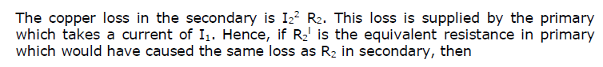

I 2 R l = I 2 R

1 2 2 2

R l = (I /I )2 R .

2 2 1 2

If no load current I0 is neglected, then I2/I1 = 1/k Hence, R l = R /k2

2 2

Similarly equivalent primary resistance as refereed to secondary is R1 = k2 R .

1 1

The resistance R1 + R l = R1 + R2/K2 is known as the equivalent or effective resistance of the transformer as referred to primary and is designated as

2

**R01 = R1 + R 1 = R1 + R2/k2.**

**2**

Similarly the equivalent resistance of the transformer as refereed to secondary

**R02 = R2 + R 1 = R2 + k2 R1.**

**1**

1. When shifting resistance to secondary multiply it by k2.
2. When shifting resistance to primary, divide by k2.

Leakage Reactance:

Leakage Reactance can also be transferred from one winding to the other in the same way as resistance.

*X*

' *X*2

*X*



2 *k*2

1

*and*

'  *k*2 *X*1

*X*01

 *X*1

* *X* '

 *X*1  *X*2

*k*2

*X*02  *X*2

2

1

* *X* '

 *X*2

* *k*2 *X*1

Total impedance

*Z*01 

*R* 2  *X*

2

01 01

*R* 2  *X*

2

02 02

*Z*02 

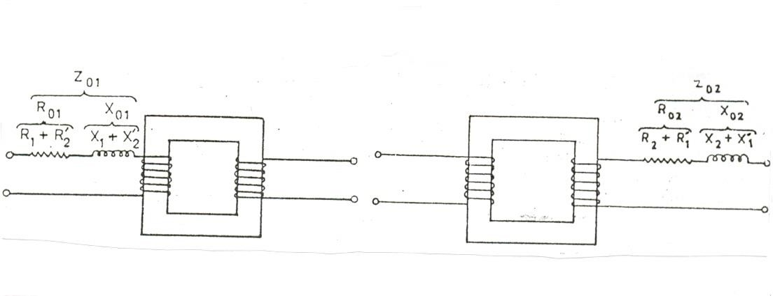

Total impedance transferred to primary and secondary side

**Example:** A 30 KVA, 2400/120 V, 50 Hz transformer has a high voltage winding resistance of 0.1  and leakage reactance of 0.22  the low voltage winding resistance is 0.035  and the leakage reactance is 0.012 , find the equivalent winding resistance, reactance and impedance as referred to

(a) high voltage side (b) low-voltage side K = 120/2400 = 1/20

R1 = 0.1  X1 = 0.22  R2 = 0.035  and X2 = 0.012 

a) high voltage side is the primary side

Hence values as refereed to primary side are

*Ro*1  *R*1

* *R*1

2

 *R*1

* *R*2 *k* 2

 0.1 

0.035

1 / 202

 14.1 

*Xo*1  *X*1 

*X*

2

1  *X*1

* *X*2

*k* 2

 0.22 

0.12

1 / 202

 5.02 

*Z*01  

*R*2

01 01

* *X* 2

14.12  5.022

 15 

b) *Ro*2  *R*2

* *R*1

 *R*2

* *k*2 *R*1

 0.035

 1 / 202 *x* 0.1

= 0.03525 

*Xo*2  *X*2

1

 *X*1  *X*2

* *k*2 *X*1

 0.012  1 / 202 *x* 0.22

= 0.01255 

*Z*02 

*R*2

02 02

* *X* 2

1

*Z*02  *k*2



*Z*01  1 / 202

0.3252  0.01255 2

*x* 15  0.0375 

 0.0374 

Equivalent circuit:

The transformer shown in (a) is resolved into an equivalent circuit in which the resistance and leakage reactance of the transformer are imagined to be external to the winding whose only function is to transform the voltage. The no-load current I0 consists of two components, Iw and I therefore, I0 is splitted into two parallel branches. The current I accounts for the core-loss and hence is shown to flow through resistance R0.The current I represents magnetizing component and is shown to flow through a pure reactance X0 .The value of E1 is obtained by subtracting vectorially I1Z1 from V1.

Xo = E1/I and Ro = E1/Iw

E1 & E2 are related to each other by the expression E2 / E1 = N2/N1 = k

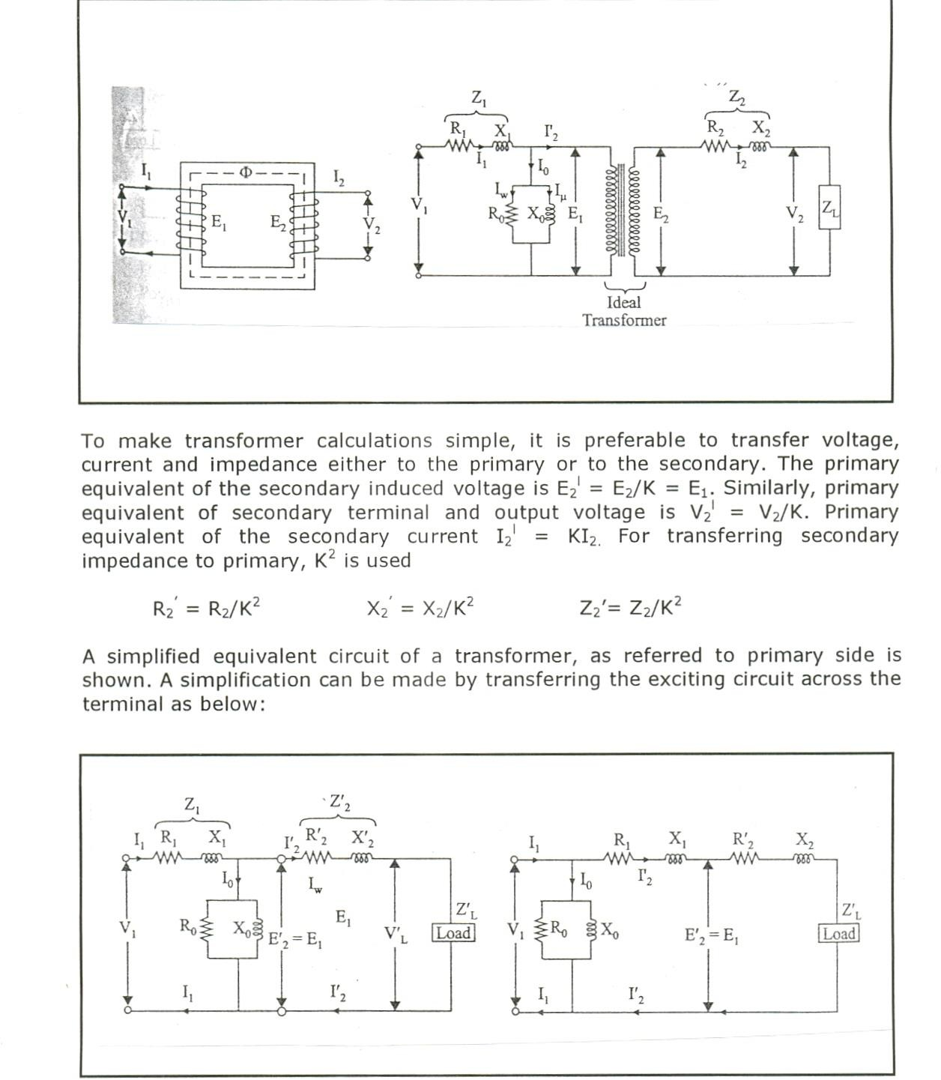

Further simplification may be achieved by omitting I0 altogether as shown below:

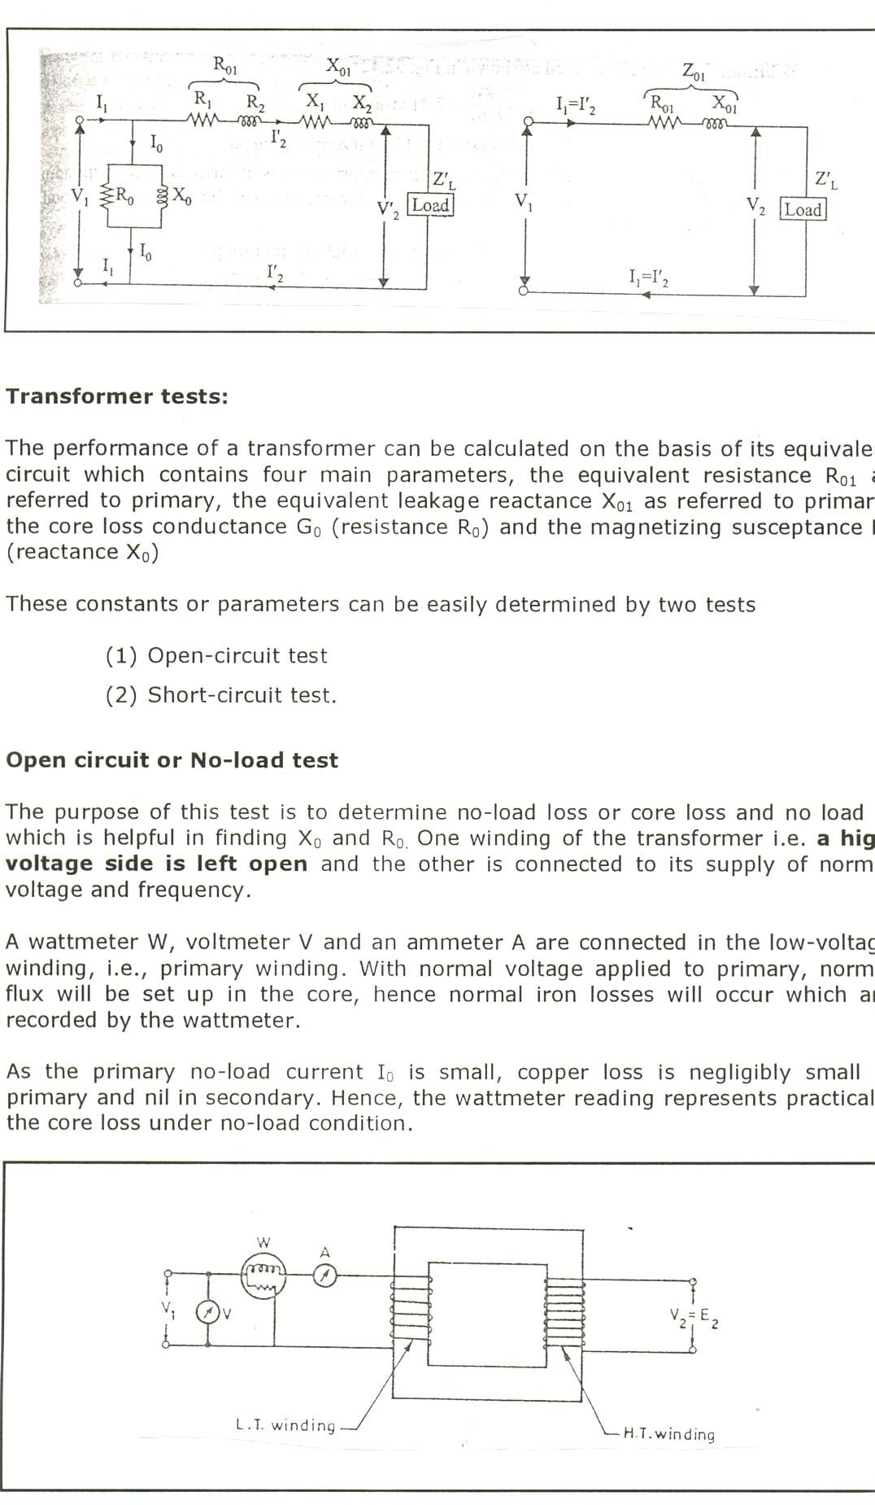

W = V1 Io cos o. Cos o = W/V1Io,

I = Io sin o

Iw = Io cos o

Xo = V1/I & Ro = V1/Iw. Io = V1 Yo

Yo = Io/V1

Go is given equation W = V 2 Go Go = W/V 2

*Y* 2  *G*2

0 0

1

1

Bo =

Short-circuit or Impedance Test:

In this test, one winding usually the **low-voltage winding is solidly short – circuited by a thick conductor.**

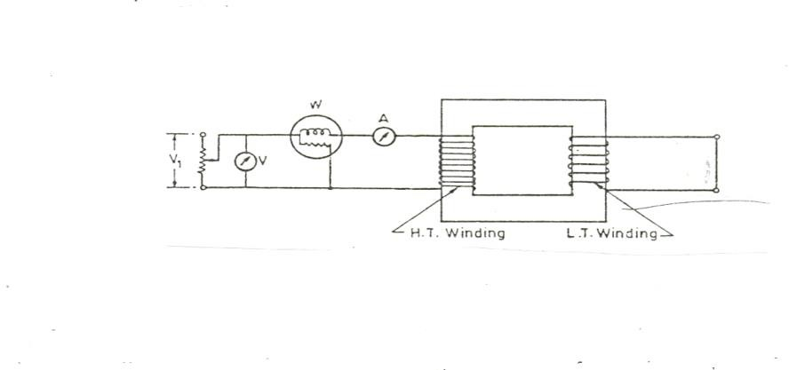

This method is used to find the following parameters.

1. Equivalent impedance (Zo1 or Zo2), leakage reactance (Xo1 or Xo2) and total resistance (Ro1 or Ro2) of the transformer as refereed to the winding in which the measuring instruments are placed.
2. Cu loss at full-load (at any desired load). This loss is used in calculating the efficiency of the transformer.
3. Knowing Z01 or Z02, the total voltage drop in the transformer as referred to primary or secondary can be calculated and hence regulation of the transformer determined.

A low voltage at correct frequency is applied to the primary and is cautiously increased till full-load currents are flowing both in primary and secondary. Since, in this test the applied voltage is a small percentage of the normal voltage, the mutual flux  produced is also a small percentage of its normal value.

Hence, core losses are very small with the result that the wattmeter reading represents the full load copper loss or I2 R loss for the whole transformer i.e. both primary copper loss and secondary copper loss.

If Vsc is the voltage required to circulate rated load currents, then Z01 = Vsc / I1

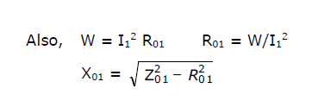

Losses in the transformer:

Losses that occur in a transformer are:

* Core or iron losses
* Copper losses

Core losses:

It includes both the hysteresis loss and eddy current loss. These losses are minimized by using steel of high silicon content for the core and by using very thin laminations.

Iron or core loss is found from the O.C test. The input of the transformer when on no-load measures the core loss.

***Hysteresis loss****:*

When a magnetic material is subjected to repeated cycles of magnetization and demagnetization it results into disturbance and there will be loss of energy and this loss of energy appears as heat in the magnetic material. This is called as hysteresis loss.

Hysteresis loss = kh Bm1.6 f x volume, watts

Where, Kh = constant

Bm = maximum flux density f = frequency

The hysteresis loss can be reduced by using thin laminations for the core.

Eddy current loss:

Due to alternating fluxes linking with the core, eddy currents get induced in the laminations of the core. Such eddy currents cause the eddy current loss in the core and heat up the core.

Eddy current loss can be reduced by selecting high resistivity material like silicon. The most commonly used method to reduce this loss is to use laminated construction to construct the core. Core is constructed by stacking thin pieces known as laminations. The laminations are insulated from each other by thin layers of insulating material like varnish, paper, mica. This restricts the paths of eddy currents, to respective laminations only. So area through which currents flow decreases, increasing the resistance and magnitude of currents gets reduced.

Eddy current loss = Ke Bm2 f2 t2 , watts

Where, Ke = constant

Bm = maximum flux density

f = frequency

t = thickness of the laminations

Copper loss:

This loss is due to the ohmic resistance of the transformer windings. Total copper loss = **I 2 R + I 2 R = I 2 R = I 2 R**

**1 1 2 2 1 01 2 02**

Copper loss is proportional to (current)2 or (KVA)2

Copper loss at half the full-load is one fourth of that at full-load.

Efficiency:

*output input*

 *output*

*output*  *cu*.*loss*

* *ironloss*

*input*  *losses input*

 1 

*losses input*

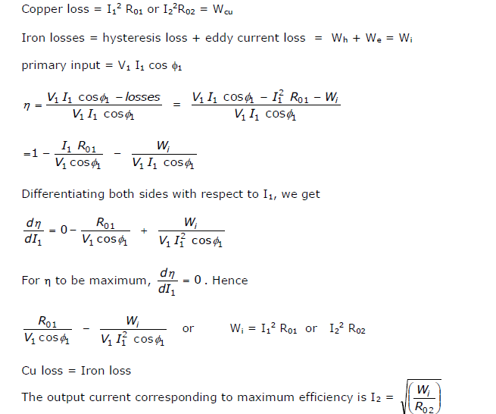

It is the value of output current, which will make the Cu-loss equal to the Iron loss.

1. If we are given iron loss and full load Cu loss, then the load at which two losses would be equal

Full load x

Iron loss

F.L. culoss

1. Efficiency at any load

**  *x* * *full*  *load kVA* * *p*.*f*

*X* 100

(*x* * *full*  *load kVA* * *p*.*f*.)  *Wcu*.  *Wi*

Transformer rating in KVA:

Cu loss of a transformer depends on current and iron loss on voltage. Hence, total transformer loss depends on volt-ampere (VA) and not on phase angle between voltage and current i.e., it is independent of load power factor. That is why rating of transformer is in KVA and not in KW.

**Regulation of a Transformer**

1. When a transformer is loaded with a constant primary voltage, the secondary voltage decreases because of its internal resistance and leakage reactance.

Let, 0V2 = secondary terminal voltage at no-load = E2 = KE1 = KV1 because at no-load the impedance drop is negligible.

V2 = secondary terminal voltage on full-load

The change in secondary terminal voltage from no - load to full-load is 0V2 – V2. This change divided by 0V2 is known as regulation ‘down’. If this change is divided by V2 i.e., full-load secondary terminal voltage, then it is called regulation ‘up’.

% regulation ‘down’ =

0*V*2

* *V*2

*x* 100

% regulation ‘up’ =

0*V*2

0*V*2

* *V*2

*x* 100

*V*2

In further treatment, unless stated otherwise, regulation is to be taken as regulation ‘down’.

The change in secondary terminal voltage from no-load to full-load, expressed as a percentage of no-load secondary voltage, is:

= Vr cos   Vx sin  (approximately)

where Vr= percent resistive drop = 100 x *I*2 *R*02

0*V* 2

Vx = percent reactive drop = 100 x *I*2 *X*02

0*V* 2

or more accurately = (Vr cos   Vx sin) + 1/200 (Vx cos   Vr sin )2

% regulation = Vr cos   Vx sin 

1. The regulation may also be explained in terms of primary values.

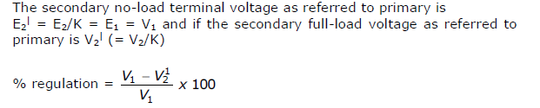

If angle between V1 and V | is neglected, then the value of numerical difference V1 – V | is given by (I1 R01 cos  + I1 X01 sin ) for lagging p.f.

2

2

% regulation = where,

*I*1 *R*01 cos**

* *I*1 *V*1

*X*01 sin **

*x* 100  *vr*

cos**

* *vx*

sin **

*I*1 *R*01 *x* 100

*V*1

 *vr*

*and*

*I*1 *X*01 *X* 100

*V*1

 *vx*

if angle between V1 and V 1 is not negligible, then

2

*x*

% regulation = *vr*

cos**  *vx*

sin**   1 *v*

200

cos**

❍ *vr*

sin ** 2

Problem 1:

Obtain the equivalent circuit of a 200/400-V,50Hz, 1-phase transformer from the following test data.

O.C. test: 200V, 0.7A, 70 W on low voltage side

S.C. test: 15V, 10A, 85 W on high voltage side

Calculate the secondary voltage when delivering 5KW at 0.5 p.f. lagging, the primary voltage being 200V.

Solution:

V1I0cos0 = W0

200 x 0.7 x cos0 = 70w cos0 = 0.5 sin 0 = 0.866

Iw = I0 cos0 =0.7x 0.5 = 0.35A I = I0 sin0 =0.7x 0.866 = 0.606A R0=V1/ Iw =200/0.35 = 571.4  X0=V1/ I =200/0.606=330 

From S.C. Test:

Z02=Vsc/I2 = 15/10 = 1.5 

Z01=Z02/K2 = 1.5/4 = 0.375 

I 2R = W; R = 85/100 = 0.85 

2 02 02

X01 = = 0.31 

Z2  *R*2

01 01

X02 = = 1.24 

Z2  *R*2

02 02

Total transformer drop as referred to secondary = I2 (R02cos2 + X02 sin2)

= 15.6 (0.85 x 0.8 + 1.24 x 0.6) = 22.2V

**** V2 = 400 – 22.2 = **377.8 V**

Problem 2:

A 100 KVA, transformer has an iron loss of 1KW and a Cu loss on normal output current of 1.5 KW. Calculate the KVA loading at which the efficiency is maximum and its efficiency at this loading (a) at unity p.f (b) at 0.8 p.f. lagging

Solution:

*iron loss F*.*L*.*Cu loss*

Load KVA corresponding to maximum efficiency = full-load KVA X

= 100 X

1

1.5

= 82.3 kVA

1. Total loss = 2 KW

**  *x* * *full*  *load kVA* * *p*.*f*

*X* 100 ;

(*x* * *full*  *load kVA* * *p*.*f*.)  *Wcu*.  *Wi*

where x = ratio of actual to full load KVA ; **** x = 1;

= 82.3 * 1

(82.3 * 1)  2

= 97.63 %

1. At 0.8 p.f lagging

 = 82.3 * 0.8

(82.3 * 0.8)  2

= 97.05 %